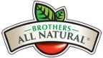
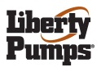
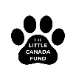
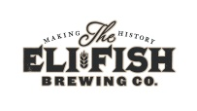
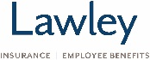
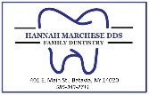
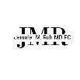
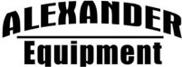
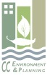

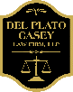
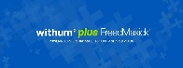
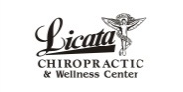

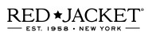
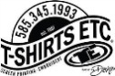


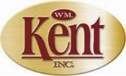
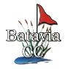
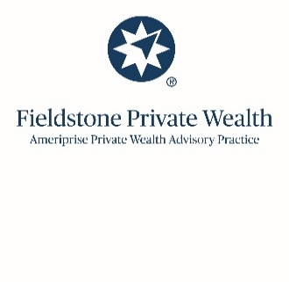


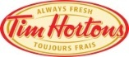
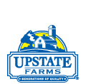
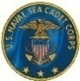
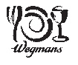
/Run for the ACORNS 2025 Sponsorships – as of 9/15/25

Banner T-Shirt Trail Sign

AWARD -1st Level 12” HGT
Brothers-All-Natural -

CORPORATE – 2nd Level 10” HGT
Liberty Pumps -

The Little Canada Fund -

BIB – 3rd Level 8” HGT
Eli Fish -

Lawley Insurance

CUP – 3rd Level 8” HGT
Dr. Hannah Marchese, DDS –

Jennifer M. Ruh, MD, PC -

T-SHIRT – 4th Level 6” HGT
Alexander Equipment -
CC Environment & Planning -

Cedar St. Sales & Rentals -
DelPlato Casey Law Firm, LLC
Withum -

Licata Chiropractic -

NYS OPWDD -

Red Jacket Orchards -

T-Shirts Etc. -

TVFCU -

Yasses Reality Group, LLC -

Wm. Kent Auctioneers -

TRAIL MARKER – 4rd Level 4” HGT
Banner Trail Sign
Batavia Country Club

David & Marcia Gann - NO LOGO – Just words

Breast Cancer Awareness - Pink Ribbon Logo

Fieldstone Private Wealth -

LeBeau - NO LOGO – Just words
Meyer’s RV -

Overhead Door

Tim Horton’s -

TRAIL MARKER – 4rd Level 4” HGT
Banner Trail Sign

Upstate Milk -

USNSCC Sullivan’s Division -

Wegman’s -

IN-KIND DONATIONS 1” HGT Banner
Batavia Restaurant Supply
Bethany Fire Department
BJ’s Wholesale
Cinquino’s Pizzeria
Coffee Press
Eastown Beverage
Eden Cafe
Genesee County Youth Bureau
Genesee County Highway Dept.
GLOW YMCA
Roanoke Orchard
Roman’s
Spotlight Theater – Warsaw
TOPS Friendly Markets of Leroy

